Requirements/Design Specification

**Additional Items Fees Not Calculating**

**GH 508 – CR 13932**

Revision History

|  |  |  |  |
| --- | --- | --- | --- |
| **Date** | **Revision** | **Description** | **Author** |
| 4/29/2015 | 1.0 | Initial Version with Requirements | Roger Behm |
|  |  |  |  |
|  |  |  |  |
|  |  |  |  |
|  |  |  |  |

The information furnished herein by Republic Services Inc. is proprietary and confidential to Republic Services Inc. personnel and is not to be duplicated, published, or disclosed to any third party in whole or in part without permission from Republic Services, Inc.

© Copyright 2012, Republic Services Inc. - All rights reserved.

Table of contents

1 Business Requirements/Owner – Brittany Smith 6

2 Assumptions 6

3 Design 6

4 InfoPro/TIBCO/BI Impacts 7

5 Report Changes 7

6 Appendix 7

# Business Requirements/Owner – Brittany Smith

See quote A1515876 in Test. The All-in-One Office additional item fees are not being included within the Estimated Monthly Fees section on the proposal. All fees for a quote should be calculated on the proposal.

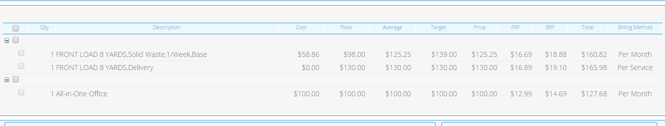

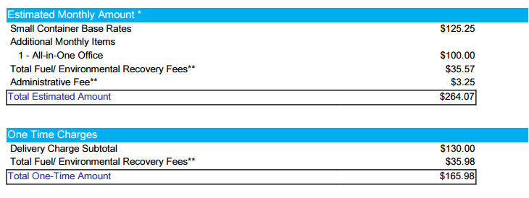

# Assumptions

NA

# Design

1. Per Haul and Per Month Additional Items are not to be included in the Proposed Price.
2. Per Haul and Per Month Additional Items are not to be included in the monthly totals anywhere in the Capture screens.
3. Costs of Additional items will be assumed and displayed as $0.00.
4. Per Haul items will be assumed to have only one haul per month.
5. Additional Items will only be displayed on the Proposal if Show on Proposal is checked for that item.
6. Per Haul and Per Month Additional Items will be displayed on the Proposal under Estimated Monthly Amount.
7. Total Fuel/Environmental Recovery Fees for Per Haul and Per Month Additional Items will be totaled under Estimated Monthly Amount in the Proposal.
8. Additional Items that are one-time charges will stay in the One Time Charges section of the Proposal.
9. Total Fuel/Environmental Recovery Fees for one-time Additional Items will be totaled under One Time Charges in the Proposal.

**Code Sections to be modified:**

* capture/commerce/quote/libraryFunctions/prePricingFormulas.java
* capture/commerce/quote/libraryFunctions/postPricingFormulas.java
* capture/commerce/quote/libraryFunctions/printing.java
* Proposal Line Items in the Documents Engine

# InfoPro/TIBCO/BI Impacts

No new variable should be needed and no existing variables should be repurposed for any of the above changes.

# Report Changes

NA

# Appendix